EASY ORDER/QUOTE REQUEST FORM
Thanks for getting in touch! Please complete the below form, save, and send back to us.
From there we can provide you with an accurate quotation and ensure you receive all the items you require.
Date | Click or tap to enter a date. | Phone Number | Click or tap here to enter text.
Name | Click or tap here to enter text. | Email Address | Click or tap here to enter text.
Company | Click or tap here to enter text. | How did you hear about us? |  | Click or tap here to enter text.
Delivery Address | Click or tap here to enter text.
ETA of your project | Click or tap here to enter text.
Step One – Choose your finish
 | 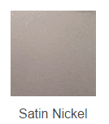 | 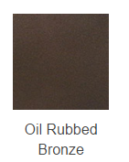
☐ | ☐ | ☐

Step Two – Choose your Ladder Hardware
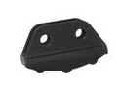
Rolling Ladder Hardware Non - Rolling Ladder Hardware
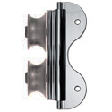 | 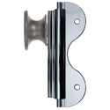 |  | 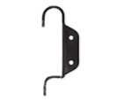
Rolling  The Rolling top roller is designed to fit onto the rail during assembly and is fixed permanently, offering more support and safety.  Can be stored in an upright position when not in use. | Rolling Hook  The Rolling Hook top roller is designed to allow the ladder to be easily lifted on and off the rail. Ideal if there are multiple rails for the ladder to interchange between.  Can be stored in an upright position when not in use. |  | Double Hook  The Double Hook allows your ladder to be hooked at the position required and then simply unhooked to move it about! The two hooks allow you to change between stored position and climbing position.  Comes with Non-Skid feet – Skip step three | Non-Skid Feet are automatically included in the Double Hook Kits.
☐ | ☐ |  | ☐

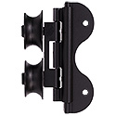
Swivel Hardware -
Swivel -
The Swivel top roller is designed to fit onto the rail during assembly and is fixed permanently.
The swivel on the top rollers enables the ladder to go over our curved rail.
Can be stored in an upright position when not in use.
Black Finish Only
☐

Step Three – Choose your Wheel Style (skip this step if you are after a non-rolling ladder)
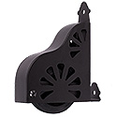 | 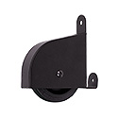
Standard Brake Wheel  Available in Black, Satin Nickel and  Oil Rubbed Bronze | Contemporary Brake Wheel  Available in Black, Satin Nickel, and Oil Rubbed Bronze
☐ | ☐

Straight Rail
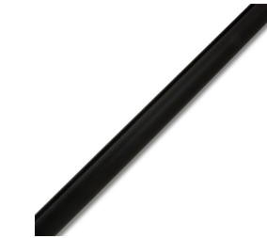 | Rail Lengths | Quantity
 | 4ft (1219mm) | Click or tap here to enter text.
 | 6ft (1828mm) | Click or tap here to enter text.
 | 8ft (2438mm) | Click or tap here to enter text.
Step Four – Choose your Rail Lengths

Curved Rail | Only Available in Black Finish
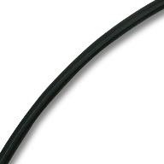 | Rail | Quantity
 | 90* Inside Corner - 16 Inch Radius – | Click or tap here to enter text.

Step Six – Choose your Brackets – Step Seven – Choose your Rail End Stops (Pair)
We will work out the number of brackets needed
based on your rail selections
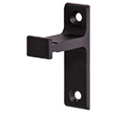 | 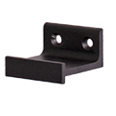 |  | 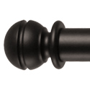 | 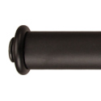
Vertical Bracket | Horizontal Bracket |  | Ball End Cap | Standard End Cap
☐ | ☐ |  | Click or tap here to enter text. | Click or tap here to enter text.

Step Eight - Choose your Ladder
Our stocked ladders are made in America and are designed to pair perfectly with our Ladder Hardware. If you are needing a custom size, please let us know, the rail height (so we can work out the ideal ladder height) and preferred wood species in the box at the end of this form.
How are you going to finish your ladder?
Paint | ☐
Stain | ☐
Height
8ft (2438mm) | 9ft (2743mm) | 10ft (3048mm)
☐ | ☐ | ☐
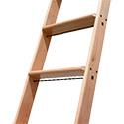

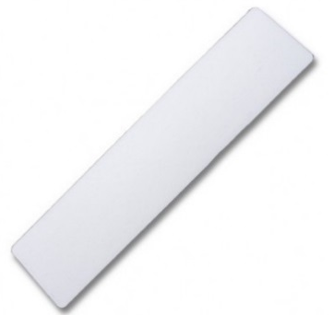
Step Nine– Extras
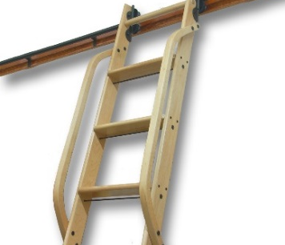

Hand Rail |  |  | Non-Skid Step Tread
Hand Rails give extra support when climbing up the ladder. We recommend these on ladders 9ft or higher. |  |  | We recommend these on all ladders. They help stop slipping and wear on the ladder rungs (only available on 16” wide ladder).
☐ |  |  | Quantity | Click or tap here to enter text.
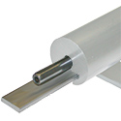

Splice Kit |  |  |  | Thread Tap
If you have selected multiple rails and wish to join them together, you will need x1 splice kit per join. |  |  |  | Needed to make threads at the end of Round Rails for End Caps (Stops)
Quantity | Click or tap here to enter text. |  |  | Quantity | Click or tap here to enter text.

Have a question or request for the RHP Team? Let us know here…
Click or tap here to enter text.
Thank you for completing the form. Once we receive this via email we will get your
order/quotation under way.
In the meantime, feel free to contact us on –
07 394 4493- office@ramhardware.co.nz- www.ramhardware.co.nz

